AIM OF THE PROJECT:
To study the phenomenon of Chemical Kinetics, understand the various factors that influence how fast a chemical reaction occurs, and to experimentally investigate the specific effect of varying temperatures on the rate of reaction between Sodium Thiosulphate ($Na_{2}S_{2}O_{3}$) and Hydrochloric acid ($HCl$).
This project also aims to explore the theoretical models behind this behavior, including Collision Theory and the Arrhenius Equation, and connect them to real-life applications.

INTRODUCTION TO CHEMICAL KINETICS:
In the study of physical chemistry, thermodynamics tells us whether a specific chemical reaction is feasible or not under given conditions. However, thermodynamics provides no information regarding how fast a reaction will occur.
The branch of chemistry that deals with the study of reaction rates and their mechanisms is known as Chemical Kinetics. The word "kinetics" is derived from the Greek word 'kinesis' meaning movement.
The Rate of a Reaction is defined as the change in concentration of a reactant or a product per unit of time. While some reactions (like the precipitation of silver chloride) occur instantaneously, others (like the rusting of iron) take years. Understanding how to control the speed of these reactions is vital in both laboratory settings and industrial manufacturing.

FACTORS AFFECTING RATE OF REACTION:
The rate at which a chemical reaction proceeds is not a constant; it is highly dependent on several physical and chemical conditions. The primary factors include:
- Concentration of Reactants: Generally, the rate of a reaction increases with an increase in the concentration of the reactants. A higher concentration means more reactant molecules in a given volume, leading to more frequent collisions.
- Surface Area: For solid reactants, breaking them into smaller pieces increases their surface area, providing more sites for the reaction to take place, thus speeding up the rate.
- Presence of a Catalyst: A catalyst is a substance that alters the rate of a reaction without itself being consumed. It does so by providing an alternative reaction pathway with a lower activation energy.
- Temperature: This is arguably the most significant factor. Almost all chemical reactions are accelerated by an increase in temperature. This project will primarily focus on the mechanics and mathematics of this specific factor.

COLLISION THEORY OF CHEMICAL KINETICS:
To understand why temperature affects reaction rates so drastically, we must first look at the Collision Theory, proposed independently by Max Trautz and William Lewis.
According to this theory, reactant molecules are assumed to be hard spheres, and a reaction only occurs when these molecules collide with each other. However, not every collision results in the formation of products.
For a collision to be considered an Effective Collision (one that yields a product), it must satisfy two main criteria:
- Proper Orientation: The molecules must collide facing the correct way so that old bonds can break and new bonds can form.
- Threshold Energy: The colliding molecules must possess a certain minimum amount of kinetic energy.
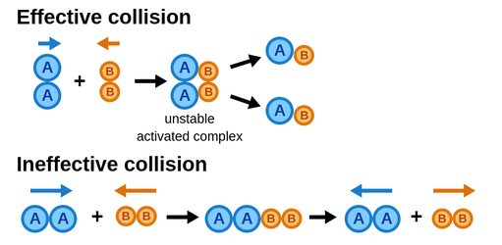
If molecules collide with less energy than the threshold energy, they simply bounce off one another without undergoing any chemical change.

ACTIVATION ENERGY:
Even if molecules are properly oriented, they need a specific energy boost to initiate the reaction. The minimum extra amount of energy required by a reacting molecule to get converted into a product is called Activation Energy ($E_{a}$).
Mathematically:
Activation Energy = Threshold Energy - Average Kinetic Energy of Reactants
When reactant molecules absorb this activation energy, they form a highly unstable intermediate arrangement known as the Transition State or Activated Complex. This complex exists only for a fleeting moment before breaking apart to form stable products.
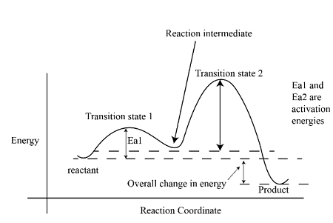
If the activation energy is high, the reaction is slow at room temperature because very few molecules have enough energy to cross the barrier. If the activation energy is low, the reaction is fast.

TEMPERATURE DEPENDENCE OF REACTION RATE:
Temperature is a measure of the average kinetic energy of the particles in a system. When the temperature of a reacting mixture is increased, heat energy is supplied to the molecules. This increases their kinetic energy, causing them to move faster and collide more frequently.
However, the increase in collision frequency alone is not enough to explain the massive jump in reaction rates with temperature. The primary reason is that an increase in temperature drastically increases the fraction of molecules that possess energy equal to or greater than the activation energy.
The Temperature Coefficient:
It has been experimentally observed that for most chemical reactions, an $10℃$ (or$10K$) causes the rate of the reaction to roughly double or even triple.
The ratio of the rate constants of a reaction at two temperatures differing by $10℃$ is known as the temperature coefficient.
$$Temperature Coefficient=\frac{Rate constant at \left(T+10\right) K}{Rate constant at T K}≈2 to 3$$

THE ARRHENIUS EQUATION:
The quantitative relationship between temperature and the rate constant ($k$) of a reaction was proposed by the Swedish chemist Svante Arrhenius in 1889. The Arrhenius Equation is written as:
$$k=Ae^{-\frac{E_{a}}{RT}}$$
Where:
- kk
= Rate constant of the reaction
- AA
= Arrhenius factor or Frequency factor (representing the frequency of collisions)
- EaEa​
= Activation Energy (in Joules/mole)
- RR
= Universal Gas Constant (8.314 J/K·mol)
- T
= Absolute Temperature (in Kelvin)
- e−Ea/RTe−Ea​/RT
= The fraction of molecules having kinetic energy greater than
EaEa​
.

